

*GRAMMAR LESSON*

by

Dzul Helmi Bin Zulkepli

AM1909006005

A

P

roject

P

roposal

Submitted to

M

ISS SHUHADAH BINTI OTHMAN

Faculty of Computing &

Multimedia

Kolej Universiti Poly

-

Tech MARA

0720



**Table of Contents**

1.0 Introduction 3

2.0 Problem Statement 3

3.0 Project Objective 4

4.0 Project Scope 4

5.0 Target User 5

6.0 Project Requirement 5

7.0 Project Planning and Methodology 6

8.0 Conclusion 6

9.0 Gantt Chart 7

10.0 References 7

# 1.0 Introduction

In this era of modern technology, there a lot of ways for student to learn from the internet in addition to school. Some student like to add or expand knowledge so I create a mobile application to someone to learns basic grammar to improve their English. My application that I build named as Grammar Lessons. As our all know, there are various races in Malaysia and foreign tourist often come to our country. Therefore, our multi-racial country and has a lot of tourists so not all of them know how to speak our main language as known as Malay language. Therefore, English will be a pleasant language for us to communicate with others. My main target users for the children because learning for young age is easier but that doesn’t mean only children can use, this open to all people want to improve they English and confident to talk with other people.

# 2.0 Problem Statement

1. Student often use incorrect and inaccurate English language.
2. Student have a sense of laziness in learning grammar because they are not interested and grammar is not important.
3. Student doesn’t like notes with long sentences and boring

# 3.0 Project Objective

1. To develop a mobile application platform that allows student to learn about Grammar in English.
2. To improve student grammar so they can use well in their life situation
3. To build and strengthen the student’s root of confidence for them to be brave to communicate in English language other than Malay language.

# 4.0 Project Scope

## 4.1 System Scope

The mobile application will have few features that will give user the best experience. Some of the features that are going to have in the mobile app are the login interface to allow user to enter into the mobile app. This system also can show notes about Grammar lesson inside it. It also has an interface that can do some exercise too

## 4.2 User Scope

There are 2 users that will use for this application, admin and student. Admin who monitors the student information who registered. The student can view notes inside it that already divided to different part and exercise.

# 5.0 Target User

1. Admin

* Admin is the one run the Grammar lesson.

1. Student

Student can access into our mobile application. The first thing that they need to do is login into the system. If they do not have any account, they are required to create an account to store their information. This mobile application can be used by public community with the age range of 7 to 12 years old. We targeted this range of age because this basic of grammar and its just normal level but if u more than 12 year old u still can use it.

# 6.0 Project Requirement

## 6.1 Software Requirement

1. Ionic Framework
2. Angular

## 6.2 Hardware Requirement

Pc

- Windows Edition - Windows 10 Pro

- Processor - Ryzen 5 3400g

- Memory (RAM) - 8.0 GB

-System Type - 64-bit Operating System, x64-based processor

- Storage -256 GB SSD

# 7.0 Project Planning and Methodology

The methodology for this mobile application is Agile Methodology. The main reason for this methodology to be chosen is because it can be breaks into several stages and the improvement is done on every iteration. Using this Agile approach, we can get what the user actually wants for their mobile application.

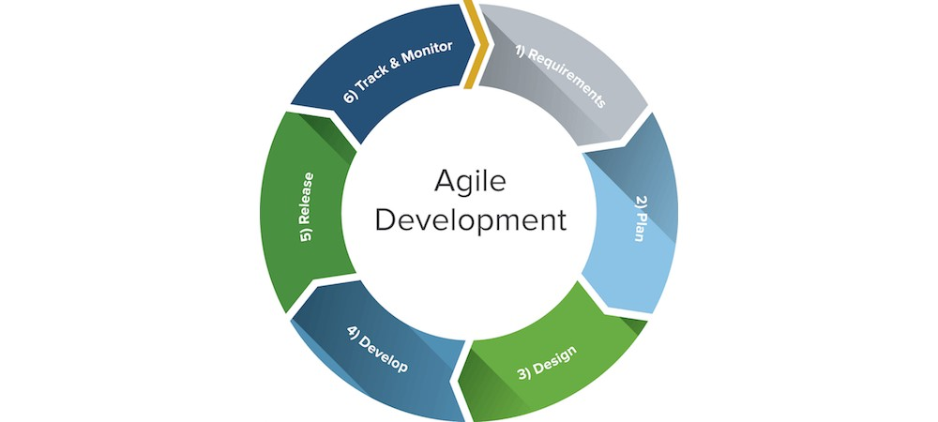

**Figure 1 Shows the Agile Methodology**

# 8.0 Conclusion

mobile phone has become an important thing to bring everywhere we go. It shows that mobile application is also one of the important things to have in the smartphone since they just need to click to the apps to use it. I hope that My Grammar Lessons Application can be developed with design and meet user’s requirement that can attract attention. I really hope this can be useful to student or anyone that uses it and give satisfaction with the app,

# 9.0 Gantt Chart

|  |  |  |  |  |  |  |  |  |  |  |  |  |
| --- | --- | --- | --- | --- | --- | --- | --- | --- | --- | --- | --- | --- |
| Project Schedule | W1 | W2 | W3 | W4 | W5 | W6 | W7 | W8 | W9 | W10 | W11 | W12 |
| Information  Gathering |  |  |  |  |  |  |  |  |  |  |  |  |
| Literature Review |  |  |  |  |  |  |  |  |  |  |  |  |
| Methodology |  |  |  |  |  |  |  |  |  |  |  |  |
| System  Requirement |  |  |  |  |  |  |  |  |  |  |  |  |
| Design |  |  |  |  |  |  |  |  |  |  |  |  |
| Implementation |  |  |  |  |  |  |  |  |  |  |  |  |
| Testing |  |  |  |  |  |  |  |  |  |  |  |  |

**Table 1 Shows the Gantt Chart for the Project Schedule**

# 10.0 References

1. https://www.makeuseof.com/grammar-apps-for-improving-english/
2. <https://magoosh.com/ielts/learning-english-grammar-in-5-easy-steps/>
3. <https://action-point.com/5-reasons-we-use-agile-project-management/>
4. https://hub.packtpub.com/9reasons-to-choose-agile-methodology-for-mobile-app-development/>
5. https://www.wrike.com/project-management-guide/faq/what-is-agile-methodology-in-project-management/